iSoLIM Help Manual

SoLIM Group
2021

State Key Laboratory of Resources and Environmental Information System, Institute of Geographic Sciences and Natural Resources Research, Chinese Academy of Sciences
School of Geography, Nanjing Normal University
Department of Geography, University of Wisconsin-Maison

Welcome to iSoLIM
iSoLIM (intelligent Soil Land Inference model) is a spatial prediction software employing SoLIM (Soil Land Inference Model). SoLIM is a new technology for soil mapping based on the third law of geography. It was designed to overcome the limitations of existing spatial prediction methods and to improve the efficiency and accuracy of soil survey. Although it was designed for soil mapping, it can be also used for spatial prediction such as landslide susceptibility mapping, wildlife habitat mapping, even epidemic disease prediction and crime mapping.

Case studies have shown that SoLIM is more efficient and accurate than traditional soil survey methods, in that it generates a range of products which the traditional approaches couldn't provide, and it can be employed in a production mode of soil survey. For more information about SoLIM, please visit the SoLIM website.

The iSoLIM software was developed through a joint effort among the colleagues at the Institute of Geographic Sciences and Natural Resources Research, Chinese Academy of Sciences, Nanjing Normal University and The University of Wisconsin-Madison, led by Dr. A-Xing Zhu, Dr. Cheng-zhi Qin. The other key developers involved include (in alphabetical order of last name):
Fang-He Zhao, Liang-Jun Zhu.

iSoLIM is currently distributed for free given that its use is non-commercial. Materials included with iSoLIM should not be copied without explicit citation of this manual. For updates and new release, please visit the SoLIM website.

Copyright 2013, 2014, 2015, 2016
SoLIM Group^{1,2,3}
1 Stat Key Laboratory of Resources and Environmental Information System, Institute of Geographic Sciences and Natural Resources Research, Chinese Academy of Sciences
11A Datun Road, Chaoyang District, Beijing 100101, PR China
2 School of Geography, Nanjing Normal University
No.1, Wenyuan Road, Xianlin University District, Nanjing 210023, China
3 Department of Geography, University of Wisconsin-Maison
550 N. Park St., Madison, WI 53706, USA

Contact Information:
Email: dsm_solim@yahoo.com
Twitter: https://twitter.com/DsmSolim
Website: https://lreis2415.github.io/SoLIMSolutions/software.html

Soil Mapping Using SoLIM
Overview
This section provides a brief introduction to soil mapping using the SoLIM approach. A list of key references on SoLIM is provided in Appendix D. iSoLIM supports soil mapping using knowledges from three types of sources: experts, samples, and data mining. Knowledges from different sources are imported and stored in a uniformed structure referred to as “prototype”. Soil mapping are based on the idea that soil types and/or soil properties can be inferred from similarity of soil-related environmental conditions (environment covariates, stored as GIS Data) between prototypes and prediction sites. Due to the utilization of environment covariates during soil mapping, the acquisition of knowledge from all data sources requires a set of environmental layers (or covariates) which depict the environmental conditions indicative of soil conditions.

Prototype
Prototype is the basic structure used for description and storage of knowledge used for soil mapping. A prototype refers to a typical combination of certain environmental conditions with certain properties. Each prototype consists of two parts: properties and covariates. Properties record all the soil type and/or soil property values of the prototype, while covariates record the environmental conditions of the prototype using fuzzy membership. Covariates consists of a set of membership functions (Figure 1) that describes the relationships between membership to the prototype (range from 0 to 1) and the environmental variables. The membership to the prototype of a prediction site can be decided by integrating the membership values of all covariate values of that prototype. The membership functions can be obtained from different sources, including experts, samples, and data mining from soil maps.
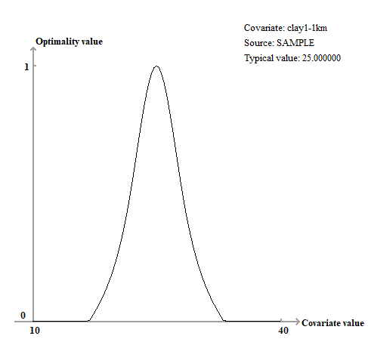
Figure 1. An example of membership function

Knowledge from experts
The acquisition of knowledge from experts require uses to manually input the knowledge needed for inference as prototypes. The three key inputs are: data on the selected covariates related to soil conditions in the area (stored in GIS Data), membership functions that describes the relationships between membership to the prototype and the environmental variables, and soil type and/or property values under the typical environmental conditions.

Knowledge from samples
The acquisition of knowledge from samples automatically extract knowledge based on samples and the covariate conditions of the prediction area. Users need to provide two key inputs: data on the selected covariates related to soil conditions in the area (stored in GIS Data), and soil samples with location and properties information.

Knowledge from data mining
The acquisition of knowledge from data mining extract knowledge from soil maps. Soil maps created through manual soil surveys contains knowledge on the relationship between soil type and environmental conditions. They are also prone to have errors from inclusion and misplacement of boundaries from manual soil surveys. Through data mining from these soil maps, the expert knowledge used for map creation can be recovered and used for digital soil mapping. The two key inputs of this type of knowledge are: data on the selected covariates related to soil conditions in the area (raster files stored in GIS Data) and soil maps in shapefile format.

Implementation
iSoLIM provides a graphic user interface to construct environmental conditions (GIS Data), to define the knowledge on soil-environment relationships from experts, samples, and data mining, and to infer the spatial distribution of soil types/properties from so-obtained knowledge. The functions are described in detail in the Reference Manual.

Reference Manual

2.1. Interface
The iSoLIM interface consists of five parts: Menu, Graphic view, Project dock, Data details dock, and Toolbar.

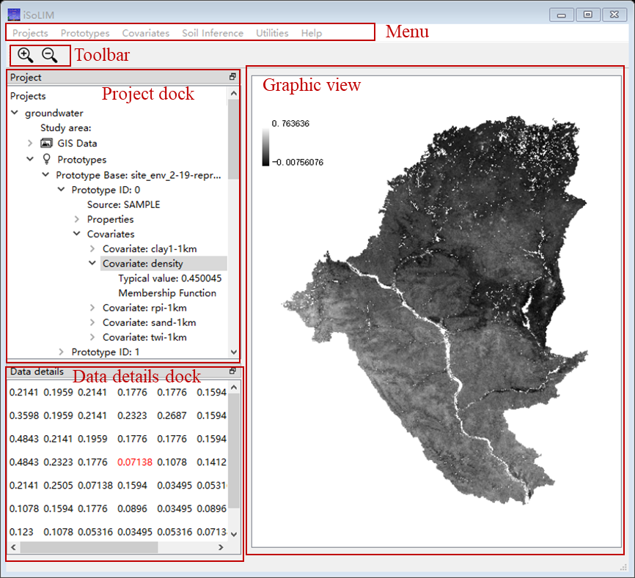
- The menu provides the interface for managing the projects, GIS Data, prototypes, inference, and other utilities.
- The project dock contains a tree-style list. It is used to control iSoLIM projects. A project consists of four child items:
  - study area (optional) where user can specify the name of the study area for project management.
  - GIS Data which depict the soil-related environmental conditions.
  - Prototypes which record the knowledge for spatial inference, and prototypes from different sources are stored separately in differently prototype bases.
  - Results, where the resultant files of the inference are displayed.
- In the graphic view, users can see the visualization of GIS data or Membership function by clicking items in the project tree.
- The Data details view displays data details of displayed graphics. When GIS data is shown in the graphic view, the data details view shows the approximate values of the raster cells at different locations when users move the mouse around the GIS data. When membership function is shown in the graphic view, the data details view displays the covariate value and its corresponding membership value.

2.2. Project
Users can start spatial inference by creating a blank project from the menu “Project New”. The inputs for creating a new project include:
- Project filename: the location and the file that the project is stored.
- Study area (optional): the study area where the inference will be conducted.

2.3. Covariates
Add Covariates
There are two ways of adding covariates that depict environmental conditions to the project:
- First is from the Menu “Covariates Add Covariate”. If a project has been created or opened, covariate will be added to existing project, otherwise, a project named “Untitled” will be created and covariate will be added to the project.
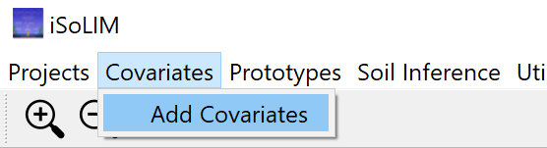
- Second is to right-click the “Covariates” on project tree if project exists, and then choose “Add Covariates”.
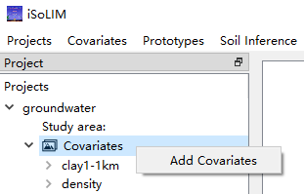
The three inputs for adding covariate are:
- Filename (Required): the filename (including path) of the covariate to be added.
- Covariate name: the layer name of the added covariate (the filename would be automatically extracted and used as layer name); it should indicate the type of environmental conditions presented in the covariate file.
- If this is a categorical covariate (checkbox): the checkbox needs to be checked if the values of covariate are categorical variables, such as land use type, parent material type. Otherwise, the covariate will be treated as continuous variable.

Delete covariate
On the project tree, right-click the covariate that needs to be deleted and select “Delete this covariate” in the pop-up menu.

Modify covariate name
If the name of the covariate needs to be modified, right-click the target covariate on the project tree and select “Modify covariate name” in the pop-up menu. Put in the new covariate name in the pop-up window.

Modify covariate file
If the file of the covariate needs to be modified, right-click the target covariate on the project tree and select “Modify covariate file” in the pop-up menu. Put in the new filename (including path) in the pop-up window.

Note:
- If covariates do not have consistent projection, resolution, column number, or row number, all covariates will be reprojected based on the spatial information of the first covariate added.
- If a covariate file does not have projection information and is inconsistent with other files in terms of column number or row number, it will not be used for computation. If it is the first covariate added, then other covariates will not be used for computation.
- Please prepare covariates with consistent projection, column number, and row number for more efficient computation.

2.4. Prototypes
Prototypes can be obtained from three different sources: Samples, Expert, and Data Mining. Prototypes from different sources are stored in different prototype bases.

2.4.1. Prototype acquisition

2.4.1.1. Add Prototype Base from Samples
Click “Prototypes” in the main menu, or right-click “Prototypes” in the project tree. Then select “Add Prototype Base from Samples”. The window for creating prototype base from samples will pop up.
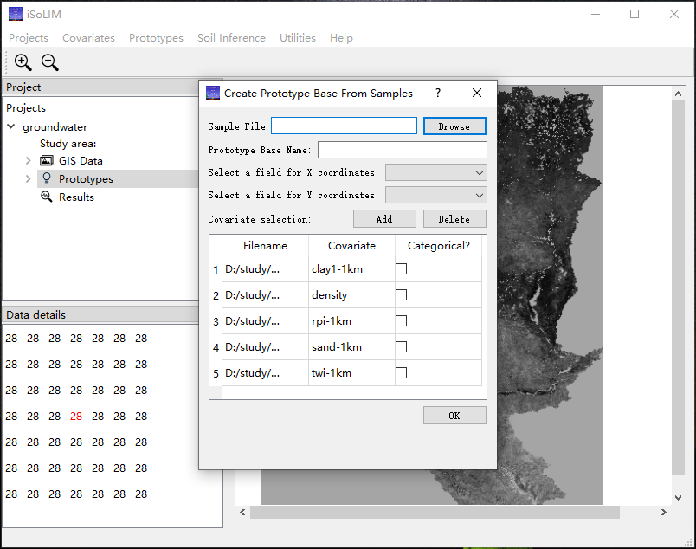
The inputs for adding prototype from samples are:
- Sample File (required): The filename with path of the samples that need to be added as prototypes. The format of sample file will be explained below.
- Prototype Base Name: The name of the prototype base. The filename of the sample file will be automatically assigned to prototype base name.
- Field names of coordinates (required): User needs to select the field name of X coordinates and Y coordinates among all field names.
- Covariates: the covariates in the project will be displayed in the table automatically. If user wants to modify covariates used for generating prototype, he/she can click “Add” button to add new covariate or select the covariate that needs to be deleted and then click “Delete”.

Sample File format
Sample file needs to be in .cvs or .txt format. It should be records of samples and their field properties. Coordinates of samples should be included in the field properties. The projection of samples should be consistent with the projection of covariates (the projection of first covariate file). Here is an example of sample file:
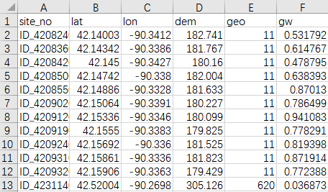
$$f\left(x\right)=e^{{\left(\frac{x-b}{d}\right)}^{2}ln\left(0.5\right)}$$

2.4.1.2. Add Prototype Base from Expert
Click “Prototypes” in the main menu, or right-click “Prototypes” in the project tree. Then select “Add Prototype Base from Expert”. The window for creating prototype base from expert will pop up. Enter the name of the prototype base to finish creation.
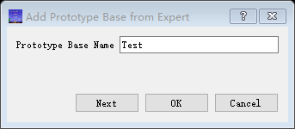
You can click “Next” to start creating prototypes from expert. Or click “OK” to finish creation. You may create prototypes from expert later by right-clicking the generated prototype base and select “Add prototype from expert”.
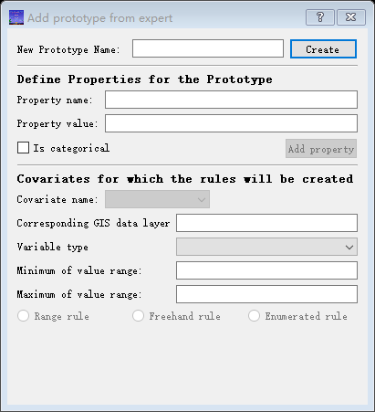
Each prototype consists of two main parts: properties and rules. After entering the name of the prototype to be created and clicking “Create”, properties and rules can be added into this prototype.

Add properties
Properties can be added at “Define properties for the Prototype” section. The inputs for adding properties are:
- Property name: the name of the property, such as “soil class”, “clay content”
- Property value: the value of the property, must be a number.
- If this is a categorical covariate (checkbox): the checkbox needs to be checked if the property is a categorical variable, such as soil class. Otherwise, the covariate will be treated as continuous variable.
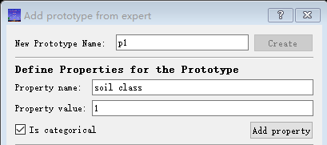

Add rules
Rules can be added at “Covariates for which rules will be created” section. Firstly, the covariate for rule creation needs to be selected. User can select the covariate that already added to the project or add new covariate.
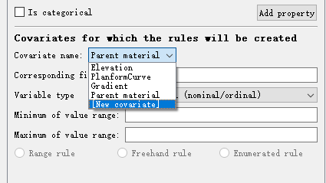
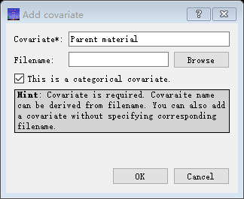

If a new covariate is added without specifying filename, user needs to specify the Variable type, Maximum of value range, and Minimum of value range before creating rules.
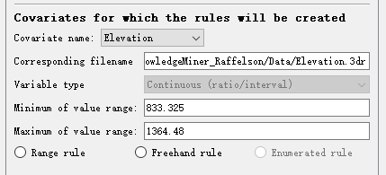

After selecting covariate for creating rules, user can select the type of rule to be added. For continuous variable, rules can be added as range rule or freehand rule, while for categorical variable, rules can be added as enumerated rule.

Range Rule
Range rules are applicable to covariates with interval or ratio values (e.g. temperature, slope). The basic idea is when certain condition is satisfied, the optimality value is 1, as the value deviates from the optimality value, the optimality decreases. This idea is expressed as the following function:
$$f\left(x\right)=e^{{\left(\frac{x-b}{d}\right)}^{2}ln\left(0.5\right)}$$
$f\left(x\right)$: the optimality value.
$x$: the covariate value whose optimality value is to be inferred.
$b$: the covariate value at which the optimality for the prototype is the highest (the most ideal).
$d$: the difference between b and the covariate value at which the optimality value is 0.5 (less typical of the specific prototype).

From the function above, some concepts can be derived:
Low Unity and High Unity:
When optimality value is the highest, the covariate value (b) can be a single value or can be a range. Low unity is defined to be the "minimum b" while high unity is the "maximum b". So Low Unity and High Unity being the same means b is a single point, otherwise, a range.

Low Cross and High Cross:
Low Cross and High Cross are the covariate values when optimality value decreased to 0.5. Low Cross is smaller than b while High Cross is greater than b.

We can derive three kinds of curves from the basic function:
- Bell-shape curve: For bell-shaped curve, optimality value decreases when environmental variable value is lower than low unity or higher than high unity. Low unity and high unity can be the same or different values. If they are equal, there is no flat top. If the difference between low unity and low cross and the difference between high cross and high unity is the same, the curve is symmetric. Otherwise, it is unsymmetrical.
- S-shaped curve: S-shape curve can be created by setting the optimality value to 1 for x greater than b. It is a "the-higher-the-better" shape. High unity and high cross values are not needed for S-shape curve. Optimality will be unity only if the environmental variable values are greater than low unity. For example, you may want a rule that indicates a particular soil is found at high elevations only. Elevations below low unity are sub-optimal, and elevations that are above low unity are optimal for the soil type.
- Z-shaped curve: Z-shape curve can be created by setting the optimality value to 1 for x less than b. It is a "the-lower-the-better" shape. Low unity and low cross are not needed for Z-shape curve. Z-shape curve is entirely analogous to the s-shape, except that the values lower than high unity are optimal.
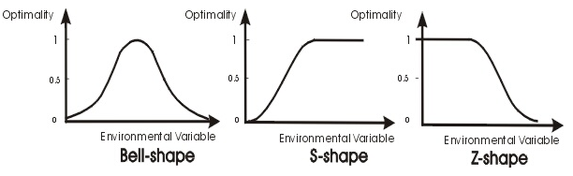

The inputs for defining a range rule includes:
- the curve type: the shape of the membership function curves, choose from Bell-shaped, S-shaped, and Z-shaped.
- the low cross (required for Bell-shaped, S-shaped): the covariate value when optimality value decreased to 0.5 (lower than low unity)
- the low unity (required for Bell-shaped, S-shaped): the minimum of covariate value when membership value is 1.
- the high unity (required for Bell-shaped, Z-shaped): the maximum of covariate value when membership value is 1.
- the high cross (required for Bell-shaped, Z-shaped): the covariate value when optimality value decreased to 0.5 (higher than high unity)
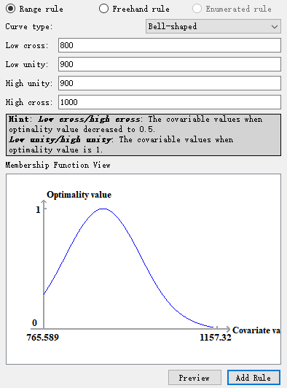
Click “Add Rule” to add the rule for the selected covariate into the prototype.

Freehand Rule
Freehand rule is flexible and can express a relationship that is overly complex. It is possible that none of bell-shaped, Z-shaped and S-shaped can effectively express the relationship. For example, there might be more than one ideal conditions, so the curve may have more than one peak. To support this kind of knowledge, we need a freehand rule. A freehand rule is used when expert (user) can provide some key points whose optimality value are known. If three or more key points are provided, the program will interpolate these points into a curve using cubic spline function. When the key points are deleted, modified, or moved, the curve will change accordingly. Expert (user) can keep adjusting the curve by deleting or/and moving the points until they are satisfied with the result.

To define freehand rules, at least three key points should be provided so that SoLIM Solutions can interpolate them into a curve. When the curve is in the shaped desired, click “Add Rule” to add the rule for the selected covariate into the prototype.

Enumerated Rule
Enumerated rules are used for categorical covariates, e.g., geology, land use type. All the possible conditions when certain soil type occurs are listed. The conditions are expressed as items (integer numbers). If the actual environmental condition matches any of the items in this list, the optimality value yielded by this rule will be 1; otherwise, the value will be 0. To define an enumerated rule, the items that will yield optimality value 1 should be provided.

You can add enumerated rules by input the item values and click “Add item that yields optimality value 1”. You can also add or delete these items by double-clicking and moving in the “membership function view”. When all items that yield optimality value 1 are added, click “Add Rule” to add the rule for the selected covariate into the prototype.

2.4.1.3. Add Prototype Base from Data Mining
Existing maps are inexplicitly embedded with knowledge of the soil-environment relationships among spatial phenomena. This knowledge can be extracted as prototypes through data mining and used for spatial prediction. Click “Prototypes” in the main menu, or right-click “Prototypes” in the project tree. Then select “Add Prototype Base from Data Mining”. The window for creating prototype base from data mining will pop up.
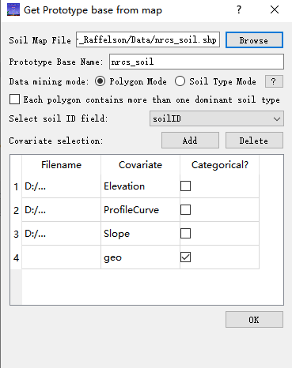

There are two data mining modes for extracting prototypes from the provided map: polygon mode and soil type mode.

Soil Type Mode
Under the soil type mode, for each soil type, a prototype is built based on the overall distribution of covariate values from all the polygons in the soil type (Qi and Zhu, 2003; Qi et al., 2008). This mode assumes that the distribution of the covariate values in a soil type reflects the membership function of rules for the soil type.

Polygon Mode
Under the polygon mode, for each soil type, rules are mined from every polygon, and then these rules are merged to generate the prototype for the soil type (Cheng et al., 2019). This mode assumes that each polygon in the soil type reflects an individual soil-environment relationship that reflects the membership of the rules. Then the rules from separate polygons need to be merges to represent the soil type.

The inputs for data mining from map include:
- Soil map file: the filename of the soil map to be mined rules from. The file needs to be in .shp format.
- Prototype base name: specify the name of the prototype base to be created. The name of the soil map file will be automatically treated as prototype base name.
- Data mining mode (Radio button): select the mode you would like to conduct data mining with.
- Soil ID field: specify the field name in the soil map file that refers to soil ID.
- Covariates: manage the covariates that used for creating rules. The covariates in the project will be added automatically.

Click “OK” after all parameters are set. The generated prototype base will be automatically added into the “Prototypes” section of the project tree.

2.4.2 Prototype management
After prototypes are added into the prototype tree, users can click on the project tree to check and manage these prototypes. Each prototype consists of two parts: properties and covariates.

Rename prototype base
If user needs to change the name of the prototype base, right-click on the prototype base whose name needs to be changed and select “Rename prototype base”. The window for changing prototype base name will pop up and you can type in the new name in it.
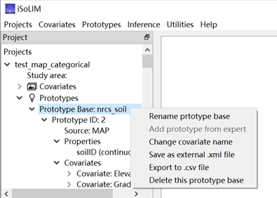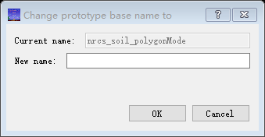

Change covariate name
The names of covariates in prototype needs to be consistent with those used for inference. User can change the covariate name for all prototypes in the prototype base by right-clicking on the targeted prototype base and select “Change covariate name”. The window for changing covariate name will pop up.
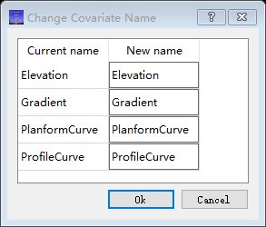
Users can change the covariate name in the column “New name”. After clicking “OK”, this change will be applied to all prototypes in this prototype base.

Save prototype base
User can also save selected prototype base as .xml file by right-clicking on the targeted prototype base and select “Save as external .xml file”. Such .xml file can be imported into other iSoLIM project later.

Export prototype base
Users can also export prototype base as .csv file whose format is more readable to users. To achieve that, right-click on the targeted prototype base and select “Export to .csv file”.

Delete this prototype base
right-click on the targeted prototype base and select “Delete this prototype base” to delete this prototype base.

Visualization of membership function
For each covariate of a prototype, users can check the membership function graph by clicking “Membership function” item under the corresponding covariate in the prototype tree.
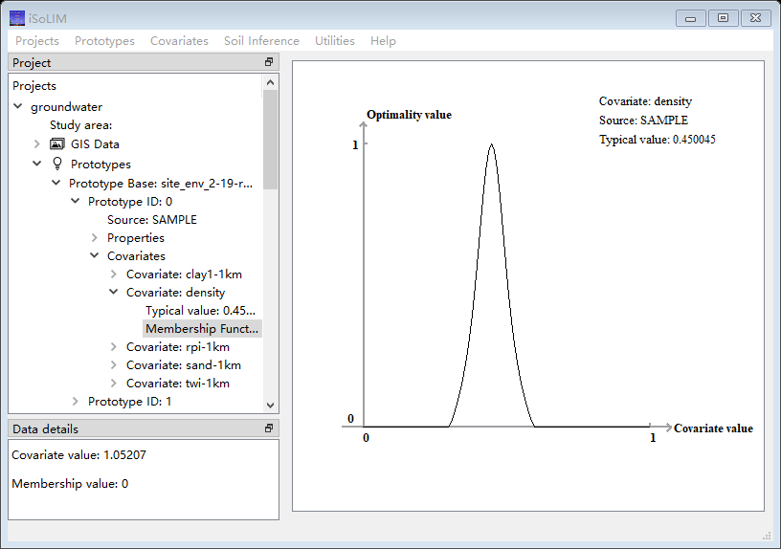

Modify covariate name
The covariate names in the prototype base need to be consistent with the covariate name of the covariates. Users can change the covariate names for all prototypes in the prototype base by right-clicking on the prototype base and select “Change covariate name”. A window for changing covariate name will pop up. In the pop-up window, user can type in the new name for covariate they wish to change.
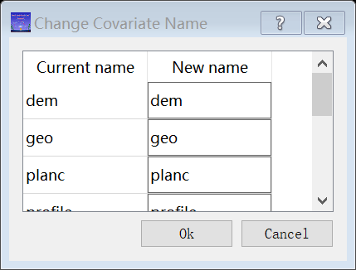

2.5. Inference
After GIS Data and Prototypes have been prepared, select “Inference” “Inference and map production” to infer the spatial distribution of interested property and produce the corresponding result map and uncertainty map. The window for inference will pop up.
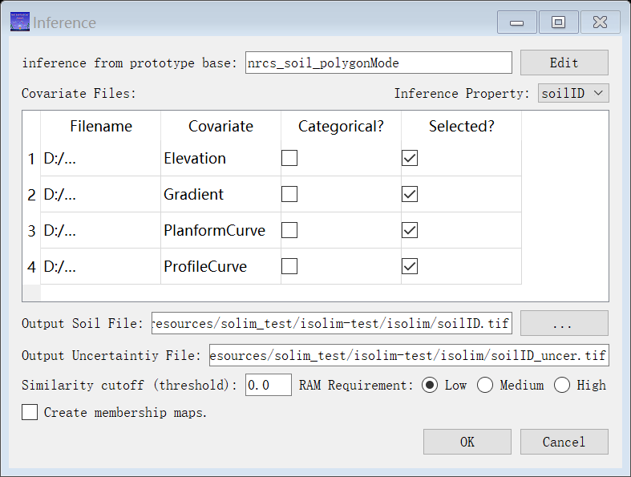
The inputs for inference include:
- Prototype base used for inference: when there are multiple prototype bases, users can click “Edit” to select which prototype bases to be used for inference.
- Covariate files used for inference: Users can click on the checkboxes in the column “Selected?” to select or unselect the covariates used for inference.
- Output soil file: specify the location and filename of the generated inference map
- Output uncertainty file: specify the location and filename of the generated uncertainty map
- Similarity cutoff (threshold): specify the threshold used for inference. For each prediction site, only prototypes with similarity measures higher than the threshold will be used for prediction.
- RAM requirement: please specify how much Random-access memory (RAM) of the computer you would like this program to use. If “high” is selected, please avoid running other computation-intensive software on the computer before the inference is done.
- (For categorical property only) If membership maps need to be created (checkbox): Check this if you wish to generate the membership maps. Membership maps will be created for each category of the predicted property, and they record the membership measure to each category at all locations.
- (For categorical property only, when membership maps need to be created) the folders for storing membership maps: specify the location for storing membership maps. Each membership will be named after the name or number of the corresponding category stored in prototypes. Please make sure the targe folder is empty.

Click “OK” when all inputs are set. After inference is done, the result will be included in the “Results” section of the project tree.

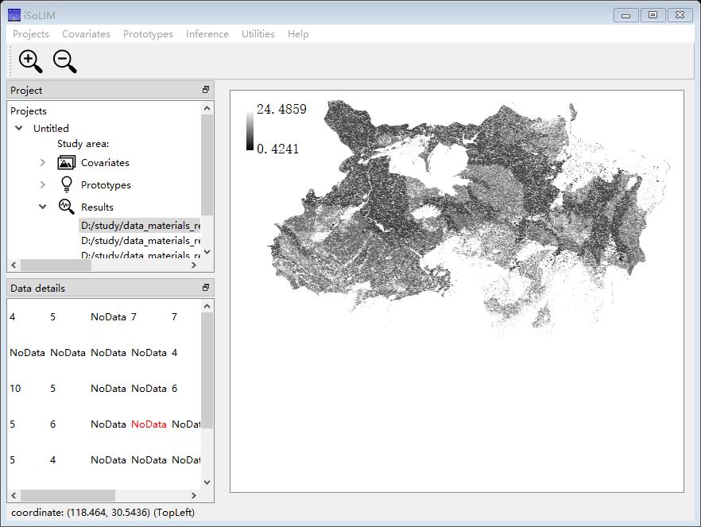

Quick Start
Here we use a case study to demonstrate how to conduct spatial inference in this software. The data used for the inference is attached in the directory “Tutorial data”.

- Create project
Select “Projects New”. Type in “groundwater” as the “Project name”, then select “Specify study area” and type in “wisconsin_river” as the study area. The study area will be attached to the project name as a suffix.
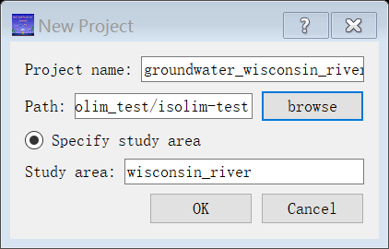
- Add covariates
Add all .tif files in the directory “Tutorial data” as covariates into the project one by one.
Select “Covariate Add Covariate”. Specify the filename and the covariate name. All test data are continuous covariates in this case study. For categorical covariate, check the checkbox “This is a categorical covariate”.
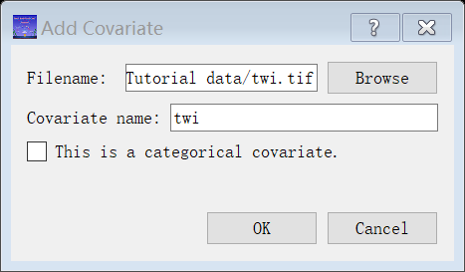
Add all 4 covariates into the project.
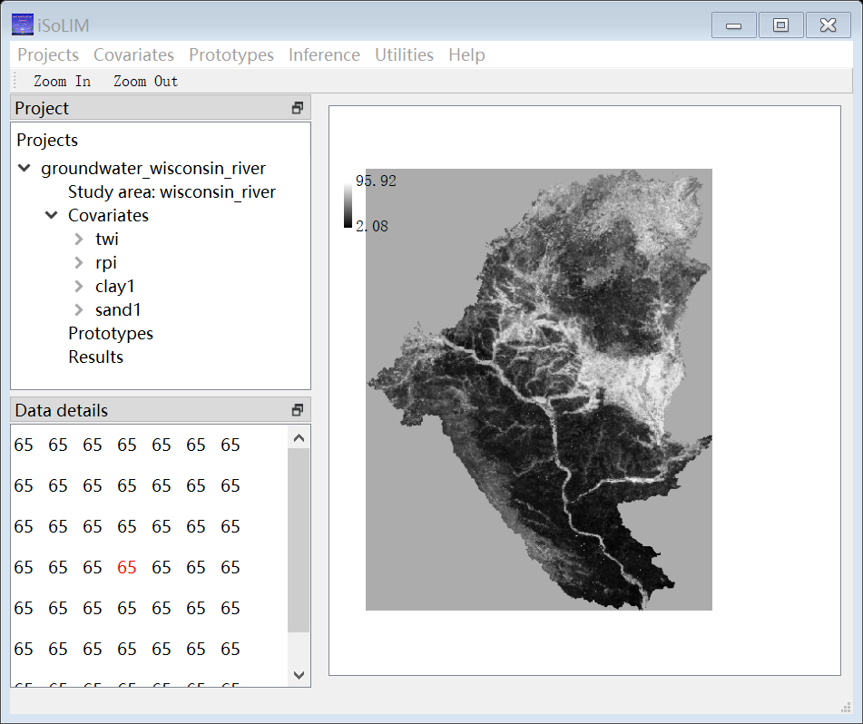

- Add prototypes
Prototypes from samples:
In this case study, we use samples as the source of the prototypes for inference. Select “Prototypes Add Prototype Base From Samples”. Select the sample file in the test data “groundwater.csv” as the “Sample File”. Then designate the field for X and Y coordinates. Select field “x” as the field for X coordinates and field “y” as the field for Y coordinates.
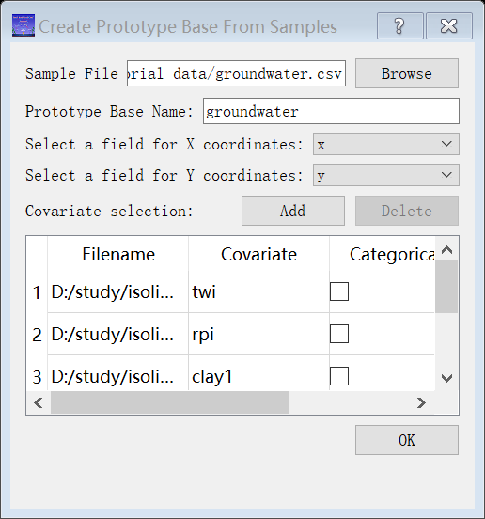
Click “OK”. Prototypes from the sample will be added into the project tree.
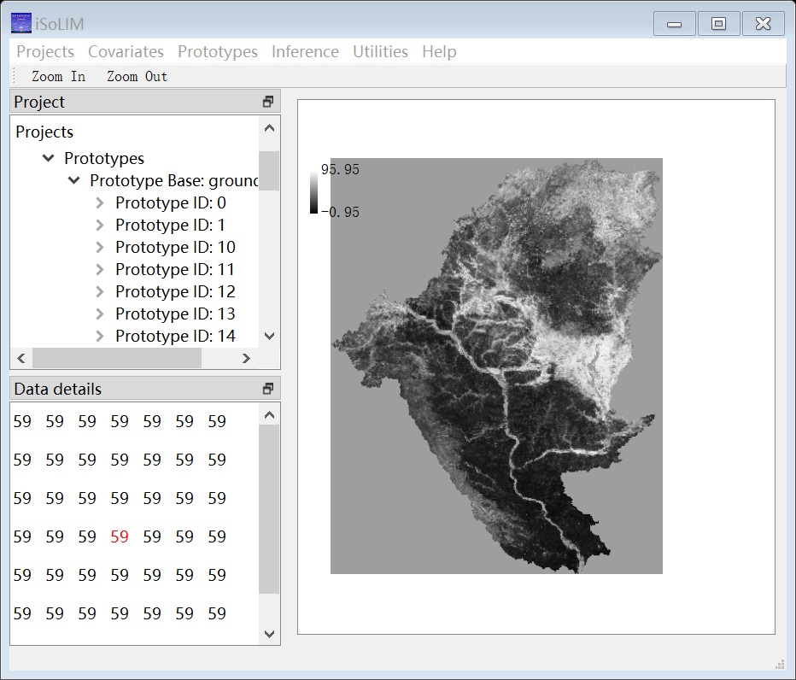

- Inference
Select “Inference Inference and map production”. Select “gw” as the “Inference Property”. Other inputs have been automatically generated:
- The output filenames are also automatically generated based on the property name.
- The similarity cutoff (threshold) is automatically set as 0.0.
- The RAM requirement is automatically set as “Low”.
Users can change the parameters as they wish.

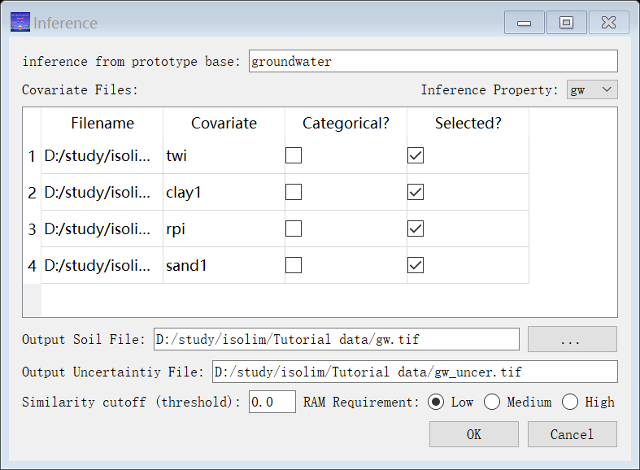

Click “OK” and wait for the inference to be done. The results will be showing in the project tree under the “Result” section.
